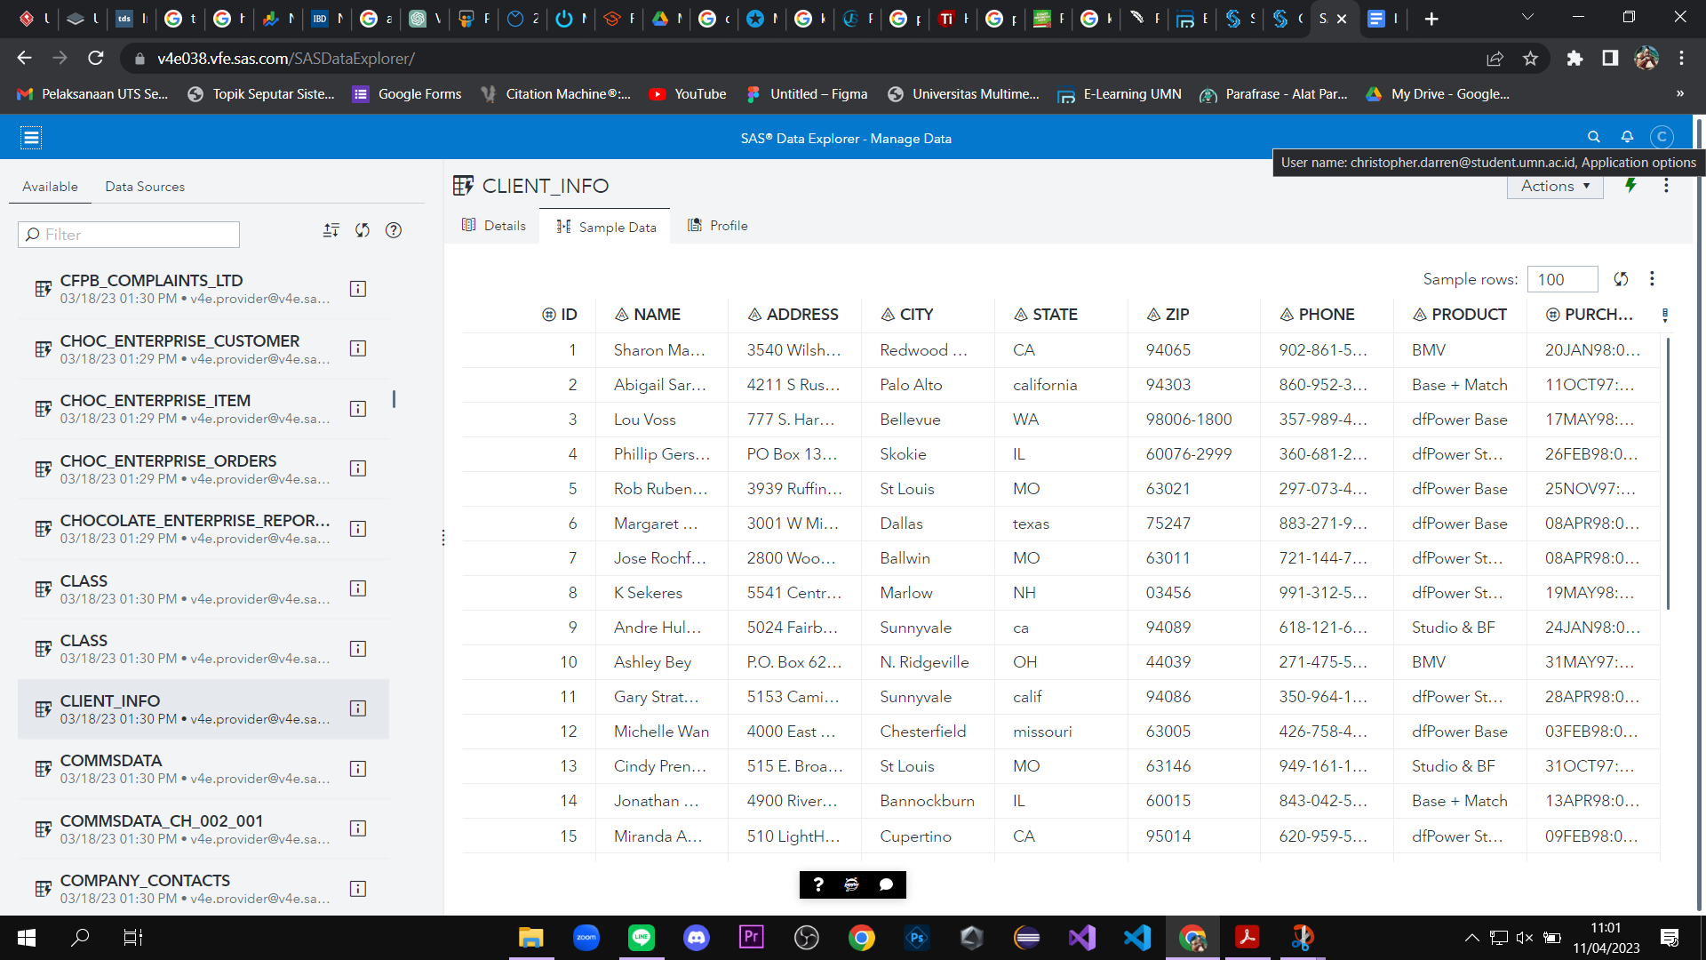

**Gambar 1.A. SAS Drive Explorer: Explore and load the CLIENT_INFO table**

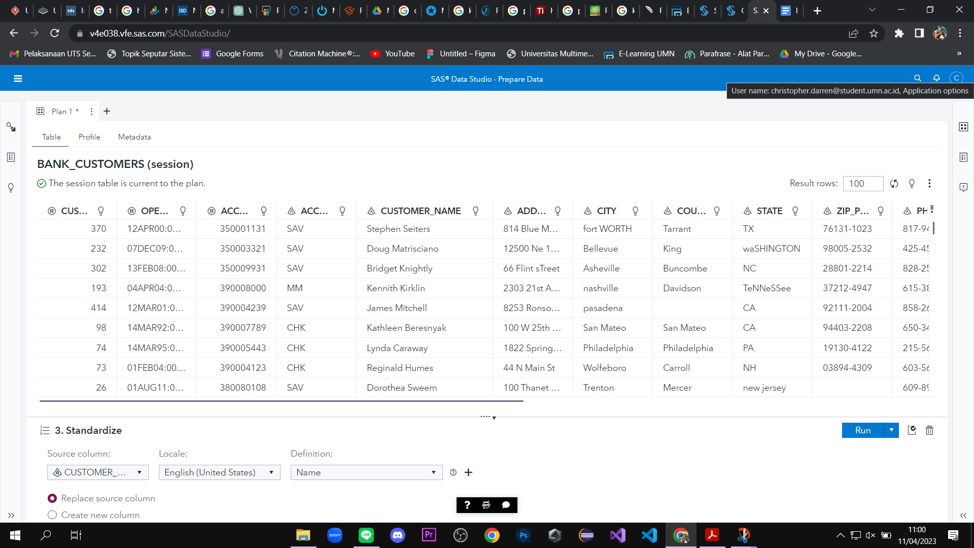

**Gambar 2.B. SAS Data Studio, Using Suggestions to Prepare Data: Standardize Customer_Name**

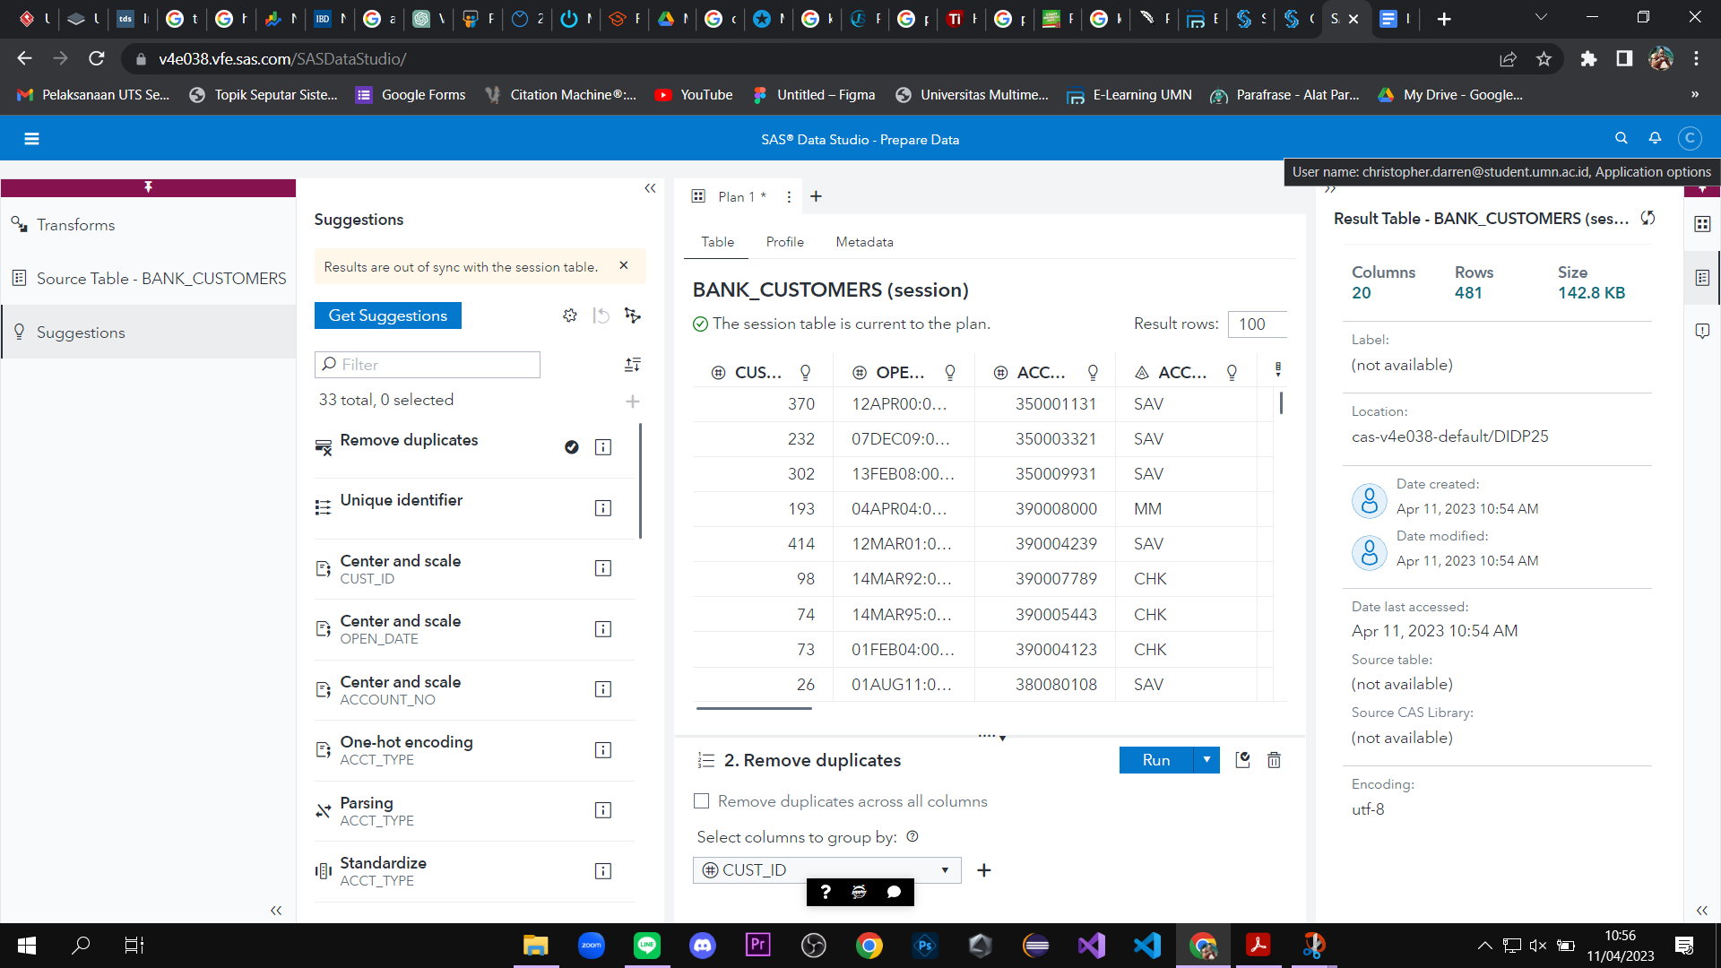

**Gambar 3. C. Add and configure the Remove duplicates suggestion**

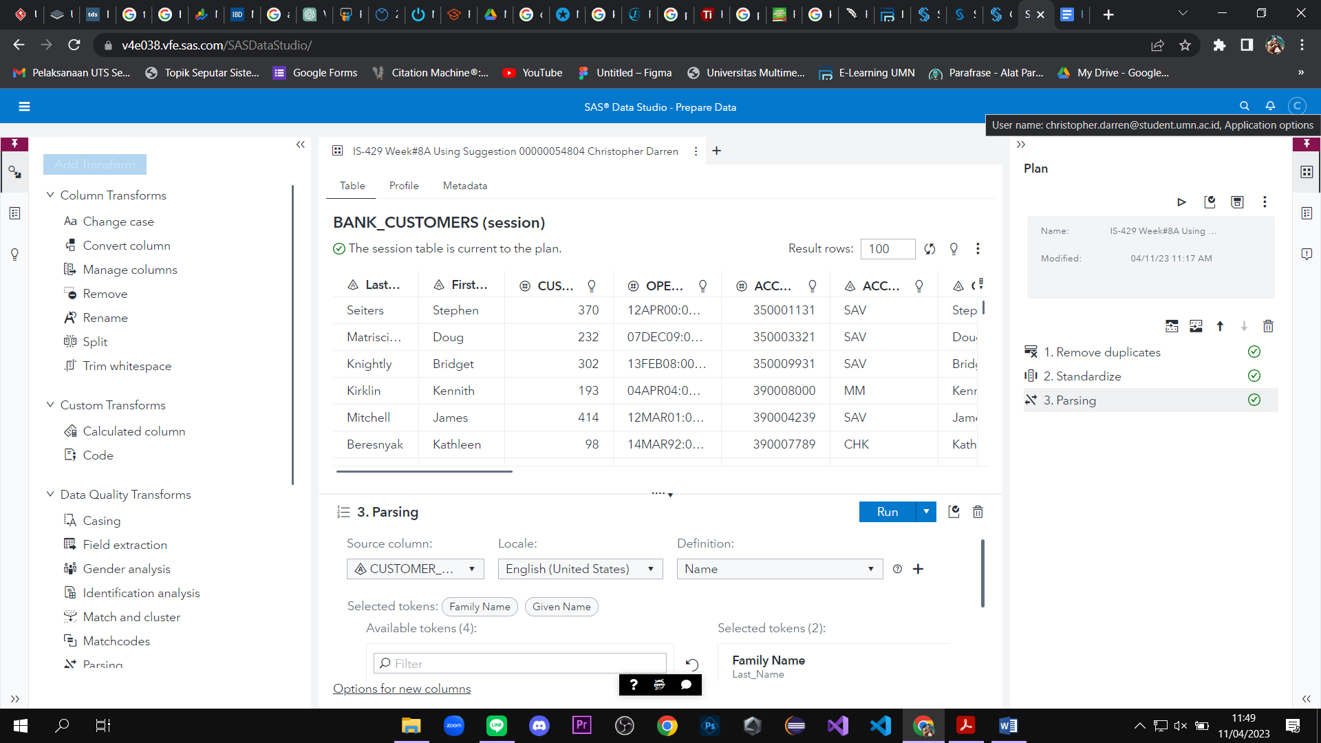

**Gambar 4. D. Add the Parsing CUSTOMER_NAME suggestion**

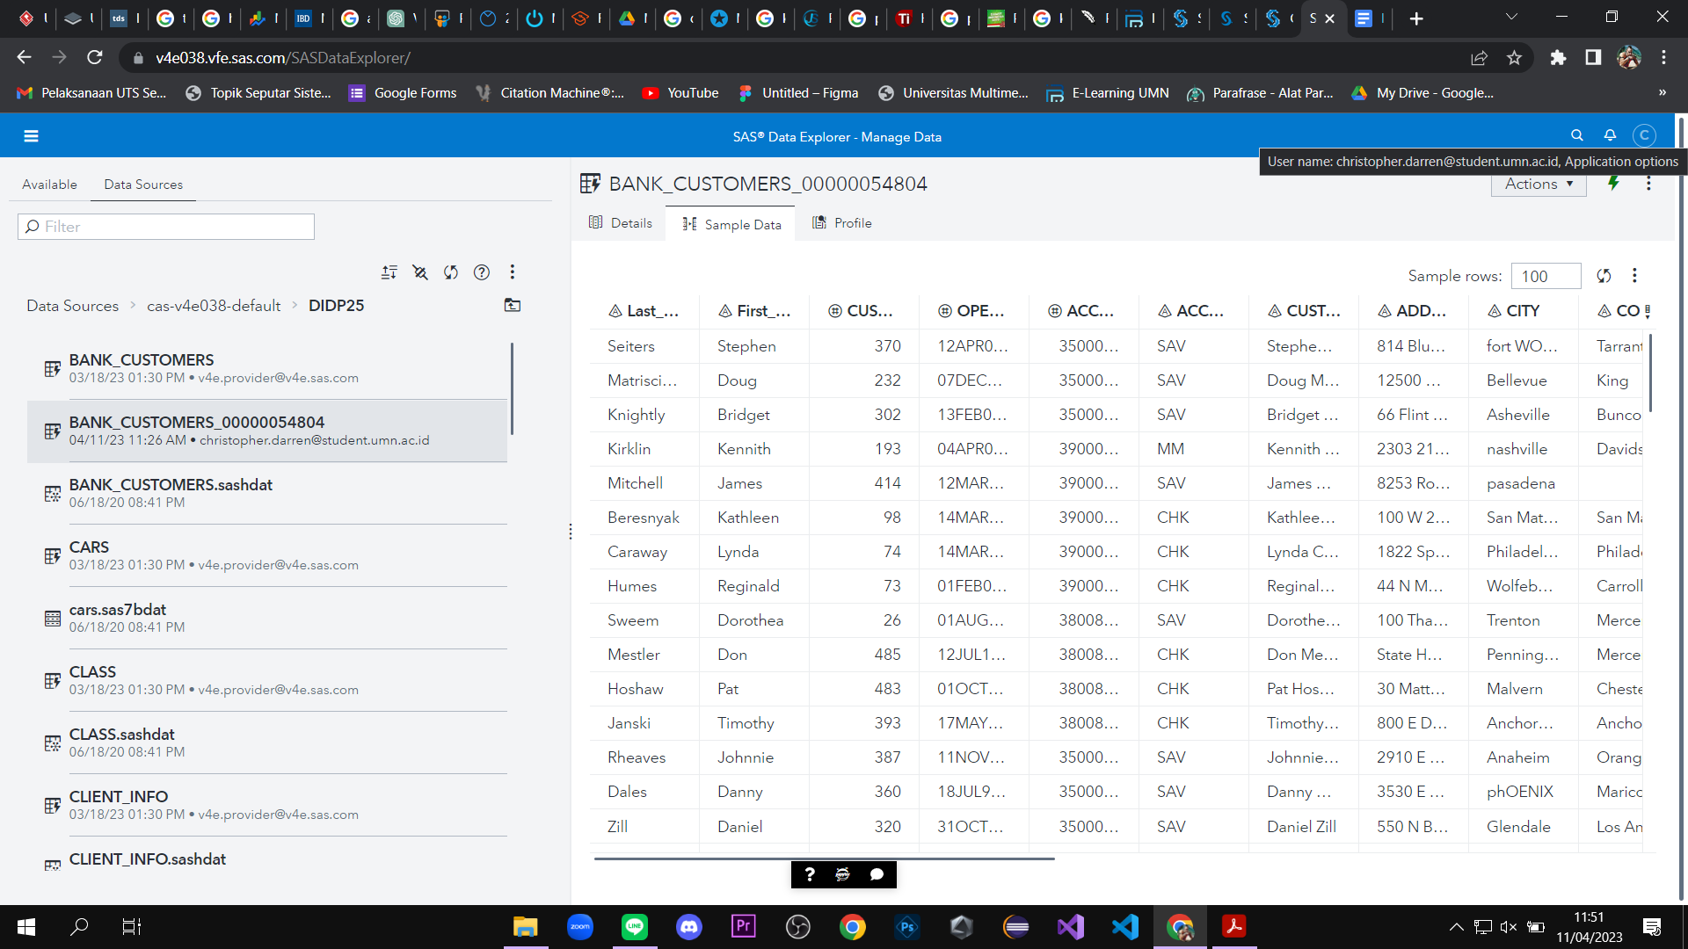

**Gambar 5. E. SAS Data Explorer: New Bank Customer of yours adding the DIDP25 CAS table.**